**AIM:** Design DFA using simulator to accept the string the end with ab over set {a,b) W= abbaabab

**INPUT:**

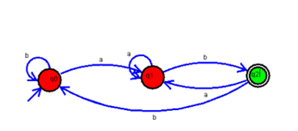

**OUTPUT:**

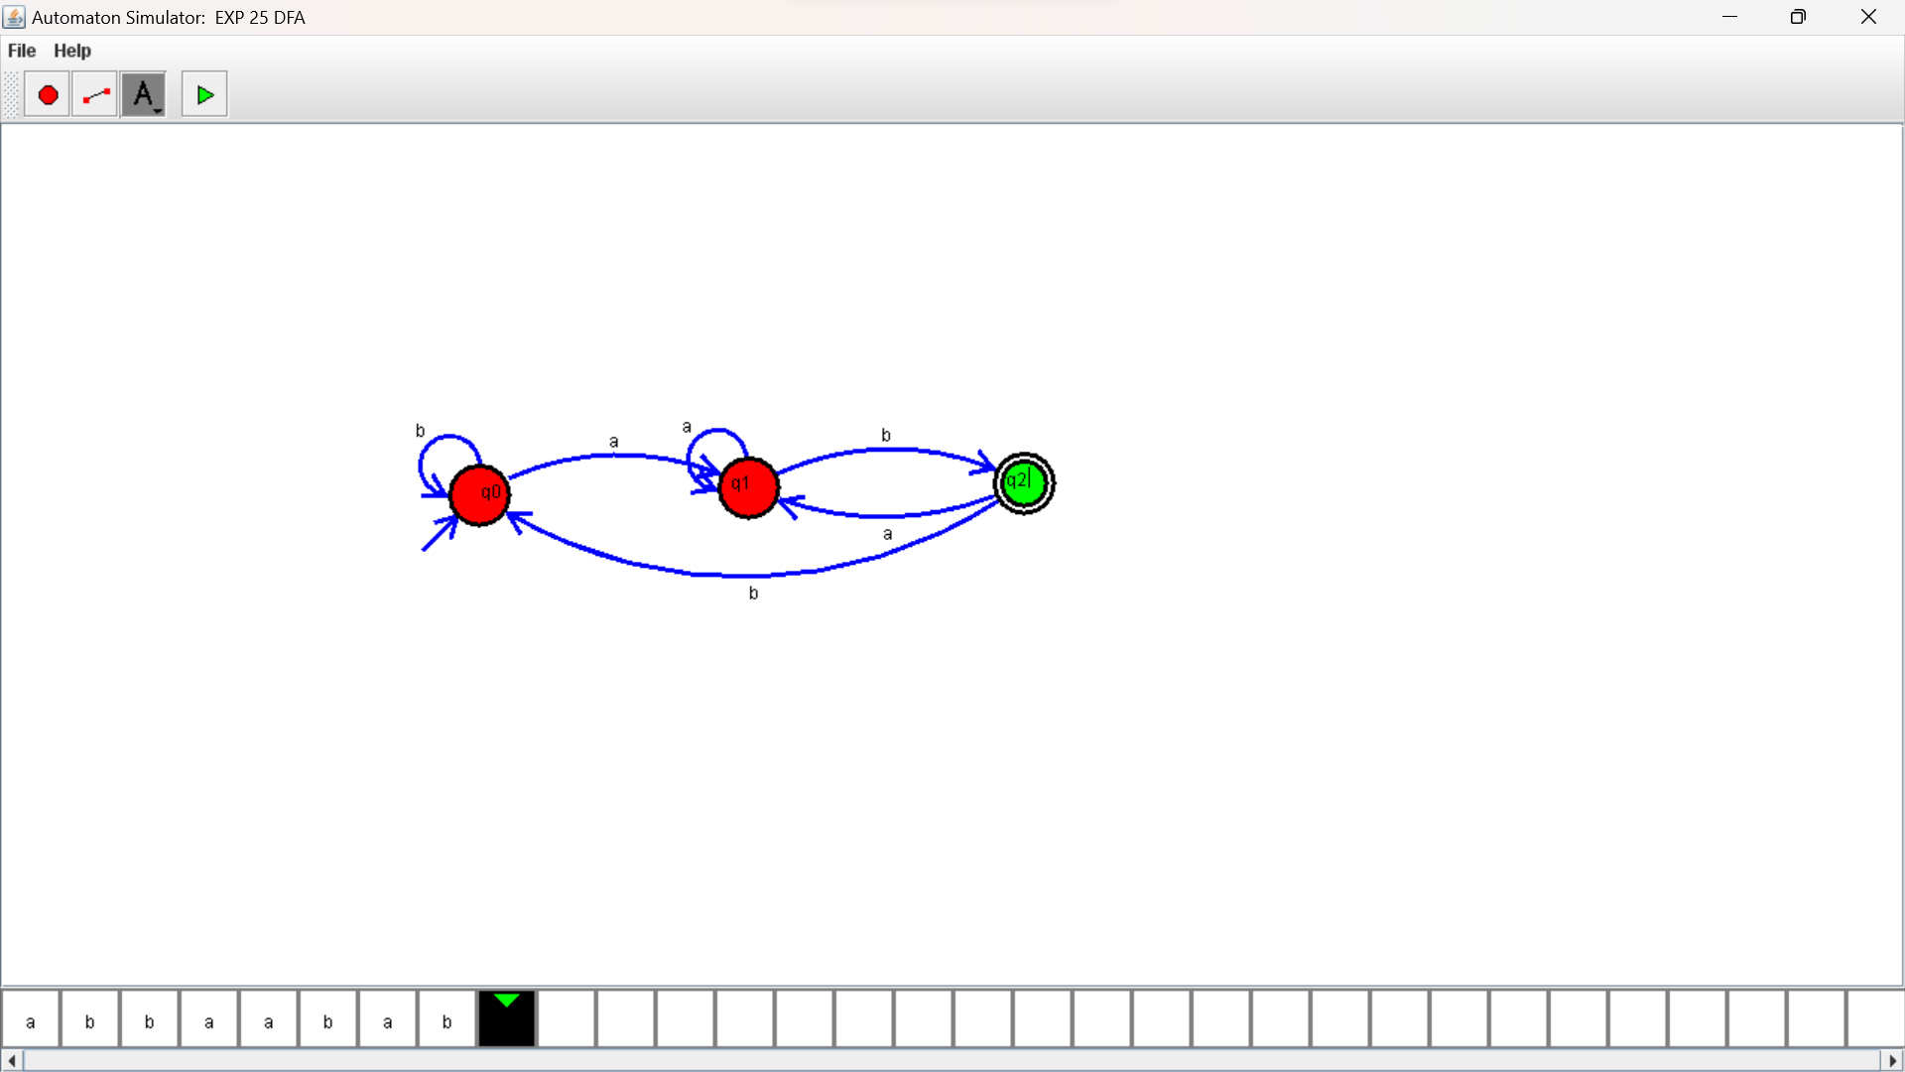

**RESULTS:**

Design DFA using simulator to accept the string the end with ab over set {a,b) W= abbaabab